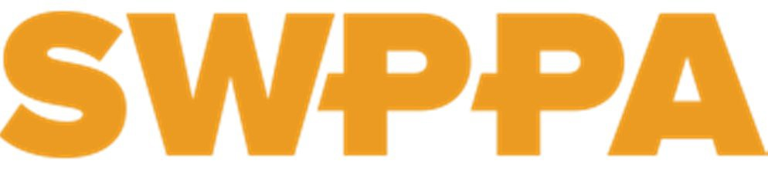

March 21, 2017

Dear Pennsylvania Representatives, Senators, and Friends:
1323 Freedom Road Cranberry Township, PA 16066
724-779-3200
info@swppa.org

We, members of the Southwestern Pennsylvania Partnership for Aging (SWPPA), write out of grave concern over Governor Wolf’s proposal to consolidate the Department of Aging with three other state departments: Health, Human Services, and Drug and Alcohol.

SWPPA is an independent, nonprofit organization dedicated to improving the quality of life for older adults in 10 counties in southwest Pennsylvania. Our 300+ members serve over a million older adults. Members include older adults, providers of services, for profit and nonprofit businesses, government entities, universities, and community members. SWPPA acts as a neutral forum for education, collaboration and the formulation of policy recommendations for older adults and those with disabilities. This letter reflects our thoughtful discussion and deliberation about the proposed change in state departmental organization.

As we learn more about the proposal, our concern is increasing and is twofold. (1) Our greatest concern is that this merger could constitute a dismantling of the Department of Aging (PDA) along with its powers and duties to represent our aging population. (2) Equally troubling is the lack of any specific and clear information within the proposal that clearly addresses how these powers and duties would in fact be preserved if PDA is absorbed within the new “super department” including the preservation of lottery funds specifically for aging services.

One of the principal powers and duties of PDA, as stated in its founding Act 1978-70, is to “Serve as an advocate for the aging at all levels of government…” As House Aging and Adult Services Committee Chairman Representative Tim Hennessey stated at the Appropriations Committee hearing on February 27th, “what position do you think would be the most effective advocate for the elderly: A Cabinet Secretary sitting beside other Cabinet Secretaries with the Governor; or a Deputy Secretary three levels down from the Governor, as the consolidation plan
proposes?”

Please understand, we certainly see the value and need for routine consolidation of Harrisburg based administrative functions, such as IT, human resources and licensing inspections, if it can be cost effective and will not cause disruption to aging services. We believe, however, this type of consolidation can be done, as it has been in the past, without dismantling the entire Department of Aging and diminishing its primary mission of advocacy for seniors and on-the- ground service delivery to seniors in the communities of our Commonwealth.

While we fully understood the need to remove conflicts identified by CMS, such as permitting the AAAs to enroll and coordinate waiver services simultaneously, DHS’s management of this issue heightens our concern. This transition from the AAAs to Maximus was incredibly harmful to countless older adults trying to remain in their communities. This leaves the appearance of our AAAs as a problem to be solved rather than an active partner and leader in addressing concerns. This resulted in the Senate and House holding a joint committee hearing in October of 2016 to insist that DHS act immediately to correct the problems. Secretary of Aging Teresa Osborne testified to the House Appropriations Committee on February 7th that “things have gotten better” but stopped short of saying that the problems have yet to be fully resolved. Without a Secretary of Aging to advocate, we fear that this leaves the aging network weakened
without an equal seat at the table.

Furthermore, we are seriously concerned about the idea of placing the lottery funds into the hands of DHS. As recently as three years ago, DHS, with Legislative approval, was withdrawing
$500 million from the Lottery fund to subsidize the General Fund for Medicaid payments. This withdrawal caused an increased waiting lists and short funding for aging programs which are funded only by the Lottery. To the Governor’s credit, he decreased the withdrawal for the past two years, but this decision appears to show a reversed course, by suggesting that dismantling the Department of Aging will provide savings to help address the General Fund deficit when in fact it will not.

As you know and as stated on page E26-4 of the proposed budget, not a single dollar of General Fund monies supports the Department of Aging or the programs it administers. The costs of the Department, including administrative costs, are paid with Lottery funds or Federal funds. Therefore, the only way dismantling the Department of Aging could help to reduce the General Fund deficit would be to shift more Lottery funds into General Fund programs.

Finally, we are very disappointed with the process by which the consolidation proposal was created. To the best of our knowledge, no stakeholder input was solicited by the Administration from within the aging network. Under questioning during the House Appropriations Committee hearing, Secretary Osborne stated that she herself was only briefed on the plan in December.

To assume that the state can begin to undertake such a massive consolidation effort in less than four months, with all of its present initiatives taking place concurrently (Community Health Choices, physical Health Choices, and proposed consolidation of two other departments), seems unwise. We believe that any plan to dismantle several Cabinet Level Departments – which has such deep and broad consumer implications – deserves more careful consideration, planning, and community input than appears to have been done in this case.

The size of Pennsylvania’s aging population will grow exponentially in the next 25 years, with a 63% increase alone in those aged 70 and older. The duties of the PDA extend beyond serving those with physical and mental health needs to promoting engagement, wellness and health for all older Pennsylvanians regardless of income. This reality clearly underscores the need for a cabinet level department representing our aging population, responsible for advocating for their needs and administering the delivery of their services at the community level. Aging

representation today is even more critical than it was in 1978, when the Legislature recognized the value of creating a Department of Aging.

The needs and potential contributions of Pennsylvania’s seniors are unique and specific. They are both an underutilized resource for civic and community engagement to the benefit of other generations and, at times, vulnerable people who are unsure where to go for help or how to access the help they need to age well. Past experiences show us that seniors attach a stigma to receiving help through a “public welfare” office. This switch will likely further alienate our aging constituents as their services are linked to public welfare programs and reduce the likelihood they will seek help or that we will prevent problems associated with aging.

With our present understanding of this proposal, it is difficult for us to see how consolidating the Department of Aging will bring any meaningful cost savings to the Commonwealth OR improve, much less at the very least preserve, the voice of and services for our aging population. Today’s older Pennsylvanians are civic minded residents who value the opportunity to actively participate in affairs that affect them.

To support such a consolidation, we would need to see clearly how absorbing the PDA into a new “super department” will provide real cost savings while maintaining or improving representation of and services for our seniors. Short of this, we cannot support the Department of Aging being dismantled.

Our members would be happy to discuss this letter, testify or engage in the process considering this change in other ways. Please feel free to contact us by phone (724-779-3200) or email (info@swppa.org).

Thank you and sincerely,
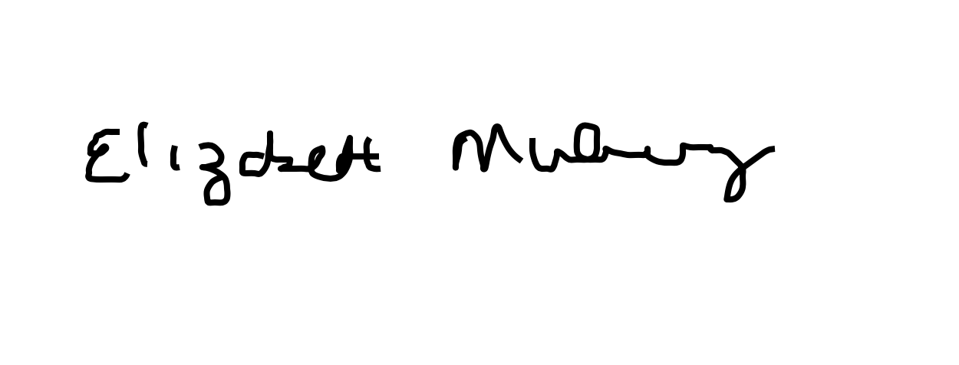
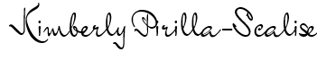
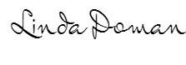
Elizabeth Mulvaney & Kimberly Pirilla-Scalise Linda Doman
SWPPA Policy Committee Co-Chairs SWPPA Board President cc: Governor Thomas Wolf and Teresa Osborne

